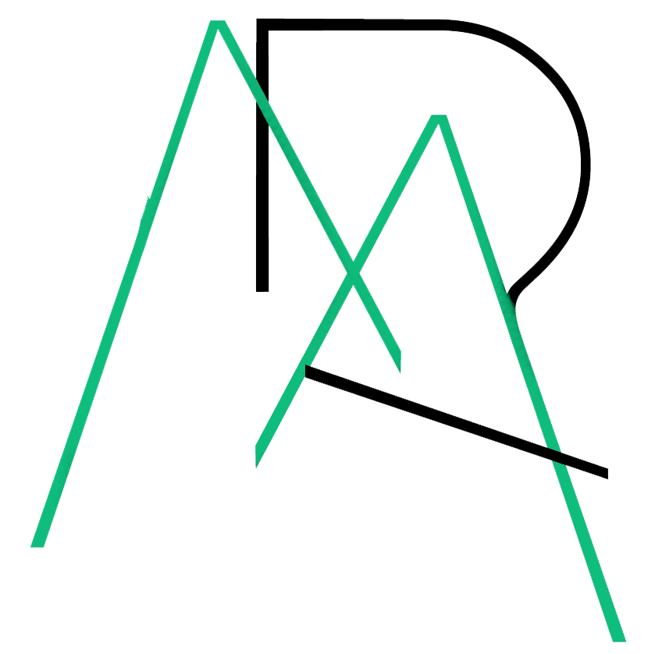 | MUDJIMBA  Residents’ Association Inc.  Minutes Annual General Meeting  6th June 2023  Mudjimba Community Hall, 41 Cottonwood St
Meeting Opened: 7.00pm
- Welcome and Acknowledgment of Country by Chair, Martin Peelgrane

- Attendees:
Members: Clint Ferndale, Fairlie McIlwraith, Loris Hetherington, Ian Hetherington, Charles Toms, Robyn Hodder-MacNeill, Martin Peelgrane, Joylene Young, Craig Walker, Trish Peatey, Robyn Harm, Narelle Richards, Delyse Toms, Rowan Stanley, Debbie Day, Ian Robinson

- Apologies: Raewyn Reid, Cleveland Maltman, Robert Walford, Elizabeth Walford, Lynley Calnan, Jo Minto, Olga Elye, Cr O’Pray

Due to only one nomination being received for the Management Positions, it was deemed a discussion re the future of the MRA should be held before proceeding with an election.
Attendees voiced their desire to retain the MRA, mainly due to the operation of the Community Hall and the loss to the community should it be handed back to the Sunshine Coast Council.
The suggestion that general meetings be held every 3 months instead of the current 2 months was well received. Members will be asked for names of possible Guest Speakers. It was also suggested that social events could occasionally replace meetings.
The secretary stated that it has proven a waste of her time lodging resident complaints via our current councillor, noting the limited success we have had, and that better outcomes have resulted when individual online complaints/feedback are made. For some reason, Council has continually failed to notify the Association of any plans for the area.
Taking dealing with Council off the table will significantly reduce the workload of the secretary and bring it back to membership and minutes.

The meeting broke for a coffee/tea break before proceeding with the Annual General Meeting business.

- Acceptance of the Minutes of the last AGM, 5 April 2022
Moved Martin Peelgrane Seconded Delyse Toms that the Minutes of the last AGM, as provided with the Notice of Meeting, be accepted as an accurate record. Carried

- President’s Report (Martin Peelgrane)
Martin thanked the executive for their contribution over the year.
He summarized the general meetings held throughout the year and encouraged all residents of Mudjimba to be actively involved as members in the Association.
The full 2 page report is attached.
Moved Martin Peelgrane Seconded Debbie Day that the President’s Report be accepted. Carried

- Financial Report (Charles Toms)
Income for the year totalled $30,140 which included a $3,000 grant. From SCRC.
Hire income remained strong and ended marginally higher than last year.
Operating expenditure for the year was $26,621, resulting in an operating surplus of $3,519.

Capital expenditure totalled $35,300 being the cost of resurfacing the parking and road areas and the upgrade to the bathrooms. These improvements were written off as the ownership of the hall lies with SCRC. The net result was deficit of ($31,780) for the year.

The consolidated bank balance decreased by $30,951 to healthy balance of $27,459 at year-end.

Moved Charles Toms Seconded Martin Peelgrane that the Treasurer’s Report be accepted. Carried

- Audited Financial Statements
Charles advised the accounts have been audited independently by Coolum Accounts & Advisors. In their report they state, “the financial report presents fairly, in all material respects, the financial position of MRA Inc as at 31 December 2022” There no issues of concern.
Moved Charles Toms Seconded Debbie Day that Audit Report and Accounts be accepted. Carried

- Declare all Committee Positions Vacant
All Committee positions were declared vacant and Rowan Stanley took the Chair.

- Election of Management Committee Member

President
As no nominations were received prior to the meeting, nominations from the floor were called. Charles Toms nominated Martin Peelgrane to the position. Delyse Toms seconded this nomination. Martin accepted the nomination but stated this will definitely be his final year. Martin Peelgrane was duly elected.
Vice President
Written nomination received from Fairlie McIlwraith. As no other nomination was received, Fairlie McIlwraith was duly elected.
Secretary
As no nominations were received prior to the meeting, nominations from the floor were called. No nominations were received. Rowan advised the meeting that the secretary could be appointed at a date no later than one month from the AGM.
Treasurer
As no nominations were received prior to the meeting, nominations from the floor were called. Martin Peelgrane nominated Charles Toms to the position. Debbie Day seconded this nomination. Charles Toms accepted the nomination and was duly elected.
Hall Manager
Martin Peelgrane reported discussions with Kathryn Hyman had resulted in her desire to accept a paid position as Hall Coordinator. Moved Martin Peelgrane Seconded Fairlie McIlwraith the she be appointed to the position. Carried
Despite a discussion calling for additional a grants officer and committee members, there were no further nominations from the floor.
It was noted that the Management Committee can appoint General Committee members throughout its term if anyone changes their mind.

- Appointment of Auditors for the 2023 calendar year
Moved Charles Toms Seconded Debbie Day that Coolum Accountants & Advisors be appointed Auditors for the 2023 Calendar Year. Carried

- Next Annual General Meeting
The next Annual General Meeting is proposed for 2 April 2024.

Meeting Closed: 8.26pm

Attachments: Presidents Report and 2022 Audited Statements

